Assignment 6

Communication Mechanisms in Embedded Systems

1.Introduction
Communication mechanisms are fundamental to embedded systems, enabling microcontrollers to interact with sensors, actuators, and external devices. These mechanisms are broadly classified into serial vs parallel communication, analog vs digital communication, and synchronous vs asynchronous protocols. Each category differs in terms of data transmission, efficiency, complexity, and reliability, playing a crucial role in real-world embedded applications.

2. Serial vs Parallel Communication
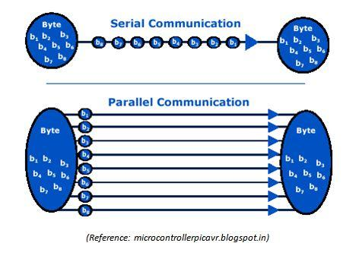

Overview
- Serial Communication transmits data one bit at a time over a single channel.
- Parallel Communication transmits multiple bits simultaneously using multiple lines.
Comparison
Data Transmission
- Serial: Bit-by-bit transmission (slower but steady)
- Parallel: Multiple bits at once (faster for short distances)
Efficiency
- Serial: High efficiency over long distances (less signal interference)
- Parallel: Efficient only for short distances due to timing issues
Complexity
- Serial: Simple wiring (fewer pins required)
- Parallel: Complex design (multiple wires and synchronization needed)
Reliability
- Serial: More reliable (less noise and crosstalk)
- Parallel: Less reliable over long distances (signal skew)
Role in Embedded Systems
- Serial protocols like UART, SPI, and I2C are widely used for sensor and module interfacing.
- Parallel communication is used in high-speed internal data transfer (e.g., memory interfacing).

3. Analog vs Digital Communication
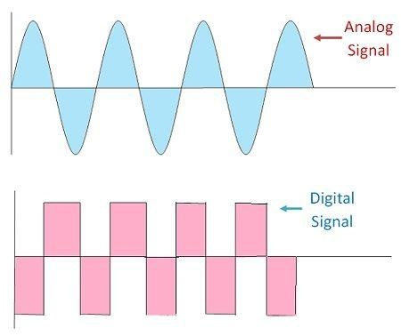

Overview
- Analog Communication uses continuous signals.
- Digital Communication uses discrete binary signals (0s and 1s).
Data Transmission
- Analog: Continuous waveform signals
- Digital: Binary data transmission
Efficiency
- Analog: Lower efficiency due to noise sensitivity
- Digital: High efficiency with error detection and correction
Complexity
- Analog: Simpler hardware but harder signal processing
- Digital: Requires ADC/DAC but easier processing
Reliability
- Analog: Prone to noise and distortion
- Digital: Highly reliable with noise immunity

Role in Embedded Systems
- Analog signals are used in sensor inputs (temperature, pressure).
- Digital communication is used in processing, storage, and communication interfaces.
- Microcontrollers often use ADC (Analog-to-Digital Converters) to process real-world signals.

4. Synchronous vs Asynchronous Communication
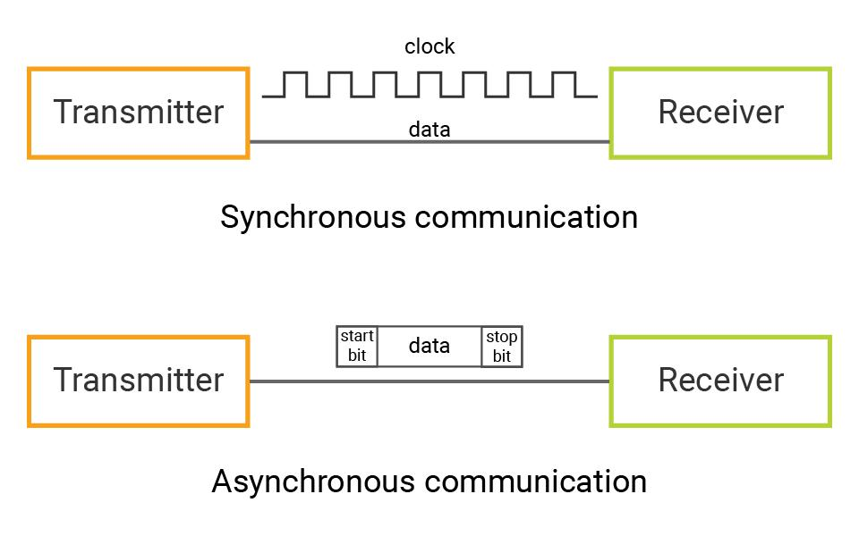
Overview
- Synchronous Communication uses a shared clock signal.
- Asynchronous Communication does not use a clock; data is sent with start/stop bits.
Comparison
Data Transmission
- Synchronous: Continuous stream with clock synchronization
- Asynchronous: Data sent in frames with start/stop bits
Efficiency
- Synchronous: High efficiency (no extra bits required)
- Asynchronous: Lower efficiency due to overhead bits
Complexity
- Synchronous: More complex (requires clock management)
- Asynchronous: Simpler (no clock needed)
Reliability
- Synchronous: High reliability in high-speed systems
- Asynchronous: Reliable for low-speed communication
Role in Embedded Systems
- Synchronous protocols like SPI and I2C are used for fast communication between devices.
- Asynchronous communication like UART is used for serial communication with PCs and modules.

5. Overall Evaluation in Real-World Applications

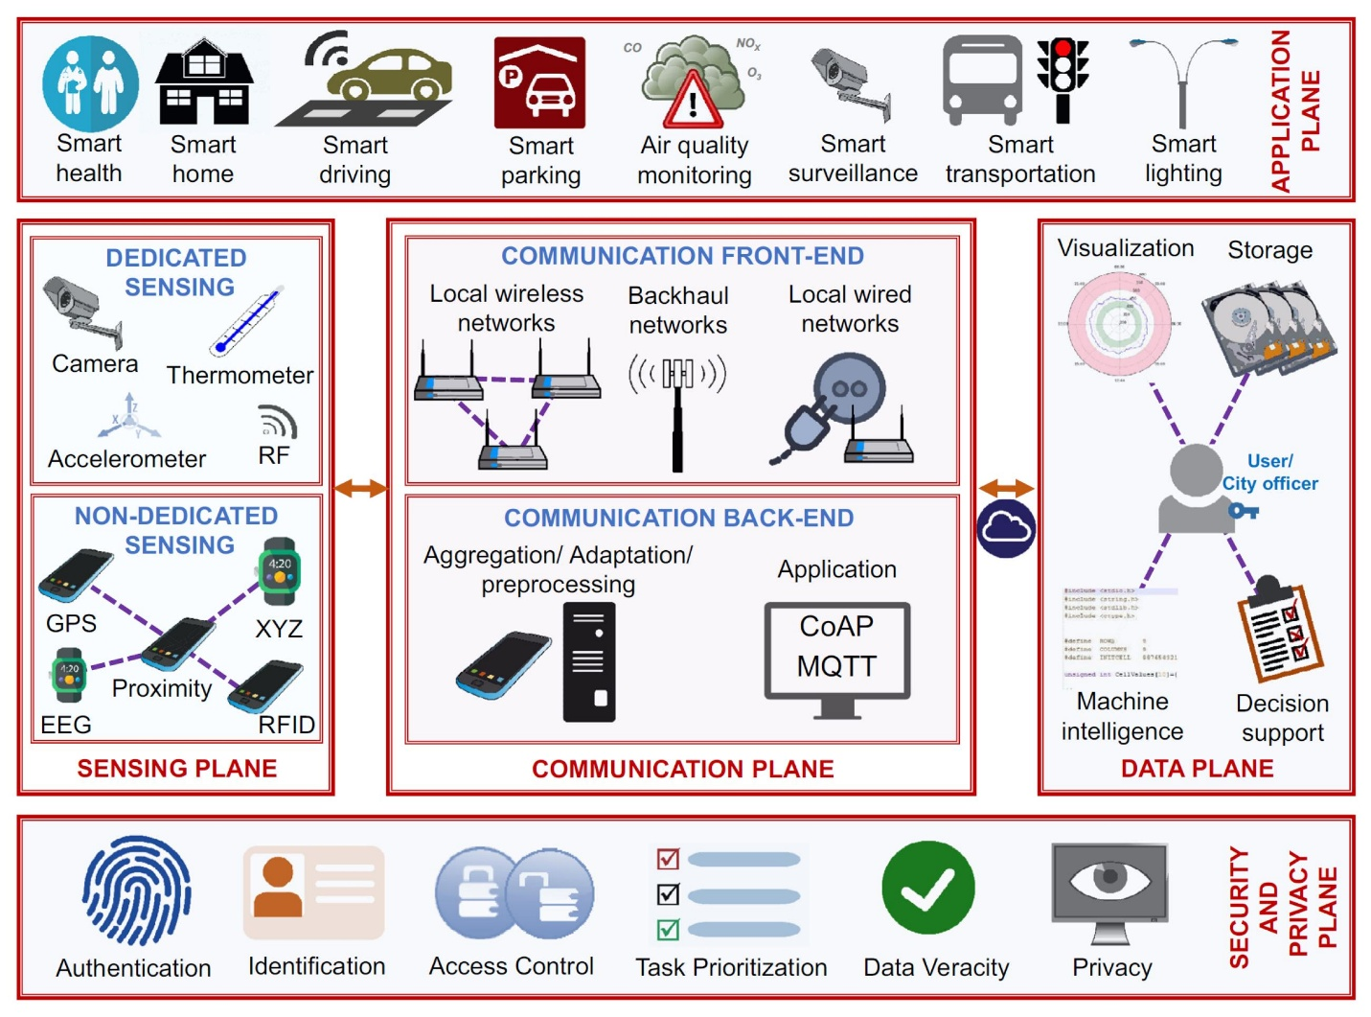
How They Work Together
In practical embedded systems:
- Analog + Digital: Sensors provide analog data → converted to digital → processed by microcontroller.
- Serial + Synchronous: Used for fast, efficient communication with peripherals.
- Asynchronous + Serial: Used for simple, low-cost communication (e.g., debugging, GPS modules).
Key Contributions
- Enable real-time data exchange
- Support interfacing with multiple devices
- Ensure efficient and reliable system performance
- Reduce hardware complexity and cost
Explanation of Each Block
1. Sensing (Input Stage)
- Collects real-world data using sensors
- Example: temperature, humidity, motion
2. Processing (Decision Stage)
- Microcontroller (like Arduino) processes input data
- Applies logic and decision-making algorithms
3. Control (Output Stage)
- Executes actions using actuators
- Example: turning ON fan, lighting LED, triggering alarm

6. Important Points (Highlight Section)

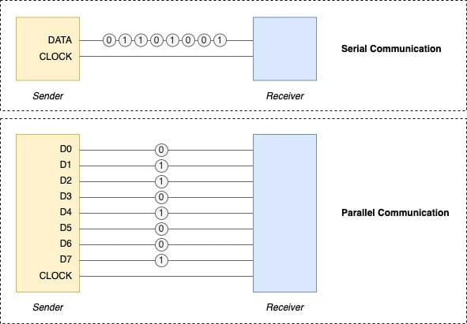

- Serial communication is preferred in modern embedded systems due to simplicity and reliability.
- Digital communication dominates due to better noise immunity and processing capability.
- Synchronous protocols are faster, while asynchronous protocols are simpler and cost-effective.
- Proper selection of communication type is critical for system performance, power consumption, and scalability.

7.Conclusion
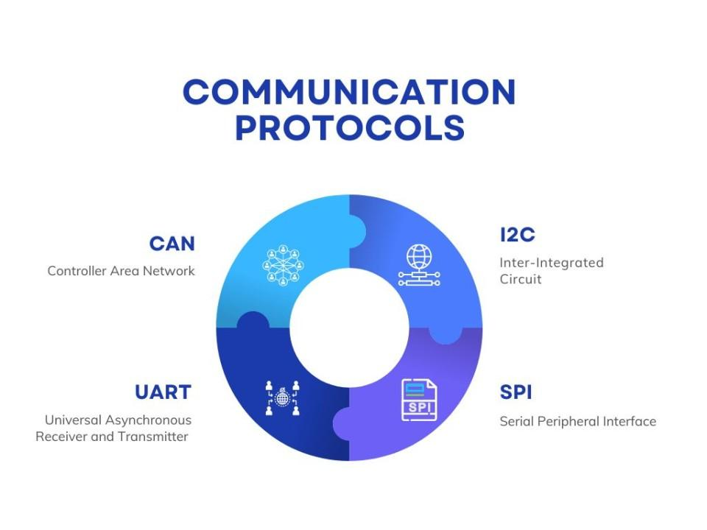
Different communication mechanisms in embedded systems serve distinct purposes. While serial communication and digital protocols are dominant in modern designs, analog signals and asynchronous methods still play essential roles. The choice depends on application requirements such as speed, cost, complexity, and reliability, ultimately ensuring effective interfacing between microcontrollers and external devices.

